

Sukkur Institute of Business Administration University
Department of Computer Science
Applied Physics BS (CS)-I
Lab-02
Verification of Ohm’s Law

Instructor: Engr: Asif Ali
Note: Submit this lab hand-out in the next lab with attached solved activities and exercises

Submission Profile
Name: Submission date:
Enrolment ID: Receiving authority name and signature:
Comments:
________________________________________________________________________________
Instructor Signature
Lab learning objectives:
- To be Familiar with the color coding of Resistors
- The objective of this experiment is to use Ohm's Law to determine the resistance of several Individual resistors. You will apply various voltages across the resistor (or circuit) using a power supply and measure the current I through the resistor and the voltage V across the resistor for each setting of the power supply.
Lab hardware and software required:
- NI Elvis-II Kit
- Resistors
- Connecting wires
- PC
- Multisim
Theory:
Ohm's Law can be written algebraically as ΔV = RI, where ΔV, measured in volts, represents the potential drop or potential difference across the conductor, I is the current in the conductor measured in amperes, and R is the resistance of the conductor measured in units called “ohms” symbolized by , upper-case Greek omega(Ω).
Note: Some textbooks use V rather than ΔV for potential difference.

Resistance and Resistors:
Resistance is a property of materials. Resistors are conducting devices made from materials, which satisfy Ohm's Law. If the potential difference across a resistor is set at 1 volt, and if a current of 1 amp is measured in the conductor, then its resistance is determined to be 1 ohm, or 1. Instead of using thin wires as Ohm did in his original experiment, you will replicate his results using small cylindrical ceramic resistors. You will notice colored bands on the resistors. These bands form a code that indicates the resistance of the resistor. Later we will discuss how to read this color code.

Measuring Current and Voltage
Measuring Current Ammeter is used to measure the current owing in a circuit. To do so, the ammeter should be connected in series with the circuit element through which you want to measure the current. Introducing an ammeter into a circuit should not affect the flow of current in the circuit and, therefore, ammeters have very low resistance.

Voltmeters are used to measure the potential difference or voltage drop across a circuit element. To do this, the voltmeter should be connected to the two points across which you want to measure the potential difference. In other words, the voltmeter should be connected parallel to the circuit element. Voltmeters should not affect the current flowing through the circuit element and, therefore, voltmeters have high resistance. This prevents current from flowing through them.

Reading the Resistor Code
The resistance of most ceramic resistors can be determined from the colored bands printed on the resistor. Each color represents a digit from 0 to 9.
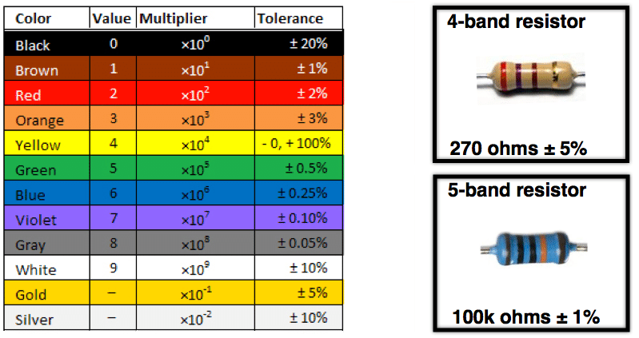

The first two bands indicate the mantissa of a number in scientific notation; the third indicates the power of ten. The fourth band indicates the tolerance or the uncertainty expressed as a percentage in the value of the resistance (gold: 5%, silver: 10%, no 4th band: 20%). Therefore, in order to know which end of a resistor to start from when reading the color code, it is useful to remember that the 4th band, if present, is metallic in color (gold or silver). If regular colors are present instead of these metallic bands, sometimes the color bands will be spaced differently or are closer to one end of the resistor to help indicate which end to start reading from. We will not be concerned with five-band resistors in this lab. If a fifth band were present, the first three bands indicate the mantissa, the fourth indicates the power of ten and the fifth indicates the tolerance (as brown, red, orange, yellow, or gold). See the example in Fig. 3 below.

Procedure: 1
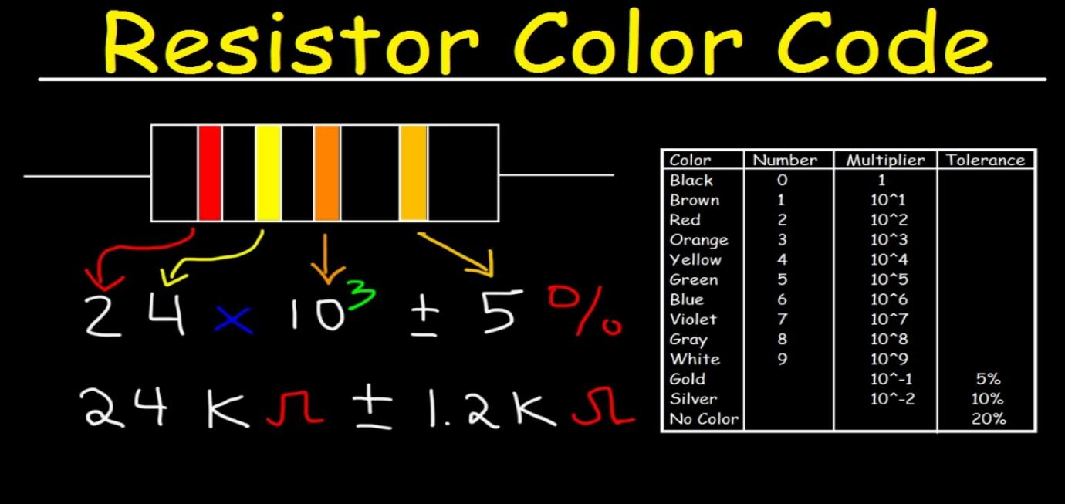

Procedure: 2
Step1: Open DMM on PC
Step2: Insert probes in the Elvis Kit
Step3: Take resistor and attach two nodes on resistor. It will display the actual value of resistor.

Worksheet
DC Circuits
As you work through the steps in the lab procedure, record your experimental values and the
Results on this worksheet. Use the exact values you record for your data to make later calculations.
Procedure A: Reading the color code of unknown resistors.
Complete the data table-1 below
Table-1
Resistor | Band 1 |  | Band 2 |  | Band 3 |  | Resistance
Resistor | Color | Value | Color | Value | Color | Value | $$Ω$$
1
2
3
4
5

Table-02
Write down actual and nominal value of resistor(s) and fill the following table.
Resistors | R1 | R2 | R3
R (Nominal)
R (Actual)

Table 3
Trial | Voltage(V) | Current(I)

Attach graph Current VS Voltage (Make graph in MS Excel)

Answer the following questions.
Qno1: Ohm’s law will generate which type of graph?

Qno-02: Why we study Applied Physics?

Q03: What are the applications of Ohm’s Law in real life?

Q04: Find the resistance of the following resistors using color coding scheme.
SNO | Resistor | Value | Range
 | 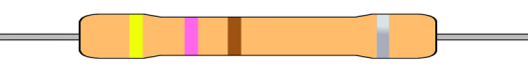
 | 
 | 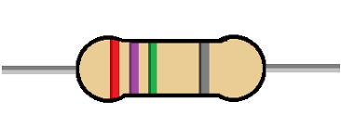
 | 